The KAIV Story

Notes:
- This story assumes that the user has used the program before & this is NOT the first time being run
- The diagrams/illustrations provided are from other software to provide a visual example of the implementation. Our program should NOT look this.

Keywords:
Window: A typical program window that has a Minimize, Maximize & Close Buttons at the top
Page: Content that is displayed within a window
Frame: Components that make up a page (e.g. buttons)
Field: Component of a page that allows user textual input

Table of Contents
Initially Running 2
First Steps (Login) 2
Creating New Block 3
Lock Options 3
Password 3
Time Range 3
Daily Limit 3
Edit Current Blocks 4
Authentication Checking 4
Check: IsLocked? 4
Check: LockType == Password 4
Check: LockType != Password && isBlockRunning 4
Else: 4
Create Deadlock 5

Initially Running
When the user opens/runs the program a window is opened and the user is greeted with a login page, this is a safety feature to ensure that it is not someone who wants to cause problems and prevent the user from using his own device.

First Steps (Login)
The login page contains one field for the user to enter their password. If the password entered is incorrect the program will display an error message.
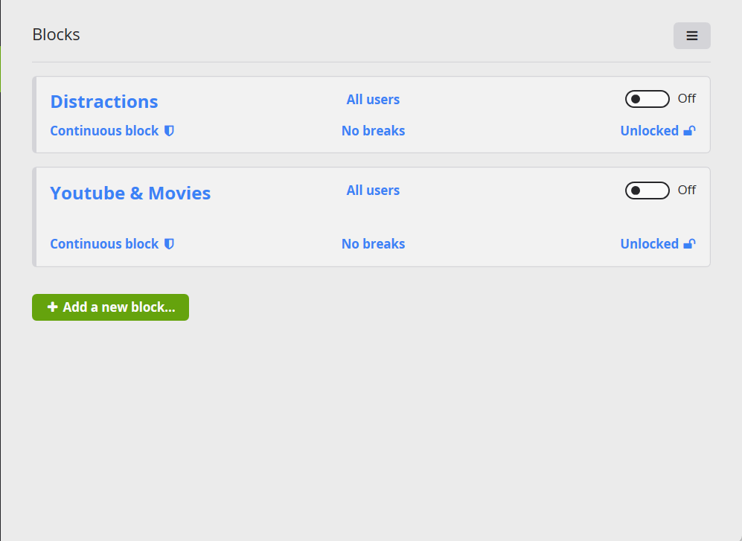
In the bottom right of the login page is a small “Get Help?” link. If clicked it will open a new small window with 4 fields to enter 4 different admin passwords. At least 2 of the 4 must be entered to bypass any authentication required. This “Get Help” link should be available in any page where authentication is required and should always provide the same functionality. (Note: Get Help will not be explained again).

Once the user has logged in a new page appears, the main page of the program. The blocks the user has created previously should appear as Frames on the page.

Possible actions on main page:
- Create new Block
- Edit current Blocks
- Create new Deadlock

Creating New Block
If “create a new block” button is clicked a new window should open. The window should have a field requesting the user to name the block with the options to proceed and to cancel. Cancel closes the window.
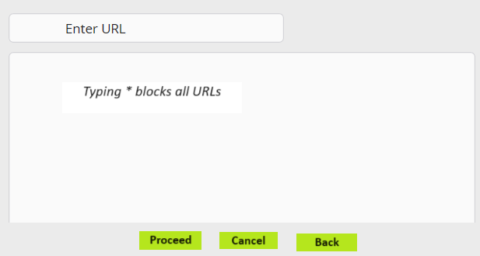
Proceed moves on to the next page with a field that asks the user to enter the website URLs to blacklist one at a time. Entering * should block all. The page should have the options: proceed, back, cancel.
Proceed moves on to the next page with a field that asks the user to enter the website URLs to whitelist one at a time. Entering * should enable all. If a whitelist URL conflicts with a URL in the blacklist of the same block, priority is given to the whitelist URL. If a whitelist URL conflicts with a URL in the blacklist of a different block, priority is given to the blacklist URL. This page should have the options: proceed, back, cancel.
Proceed moves on to the next page with a field that asks the user to enter the applications to block one at a time. Entering * should block all. The page should have the options: proceed, back, cancel.
Proceed moves on to the next page which asks the user to choose a type of lock. A lock secures and prevents a block from being edited while it is enabled. The lock options include: None, Password, Time Range & Daily Limit. The page should have the options: save, back, cancel.

Lock Options

Password
- Password option opens a new window containing 2 fields.
  - Type new password.
  - Verify password.

Time Range
- Time Range option opens a new window containing 2 fields/frames.
  - Start time.
  - End Time

Daily Limit
- Daily Limit option opens a new window containing 2 fields.
  - Time measurement (e.g. hours/minutes).
  - Daily Limit (e.g. 7 hrs)

Save should create an instance of the type Block in the background with all the entered details. (Note: within the Block object, other objects may be instantiated, e.g. Lock). Save will also add a new Block Frame to the main page.

Edit Current Blocks
On the main page, the user should have the option to edit previously created blocks.
These options include (but may not be limited to):
- Stop/Start.
- Delete.
To implement any edits it will check if the user is authorized.

Authentication Checking

Check: IsLocked?
This includes checking if there is a Lock. If Yes ...

Check: LockType == Password
Check if lock type is password. If is password, open window requesting user to enter password. If password is incorrect display error message. This window should have “Get Help?” link at bottom.

Check: LockType != Password && isBlockRunning
If not password (Daily limit, Time Range), check if the Block currently running. If Yes, is running, open new window with Error message “Not Authorized to make edits because currently running” This window should have “Get Help?” Link at the bottom.

Else:
If not password & is not running allow user to make edits.

Other edit options (Rename, Unlock/Lock, add URLs) will simply open the Block’s implementation window after authentication.

Create Deadlock
On the main page, the user should have the option to create a Deadlock. It will follow similar process to creating a new Block. New window:
naming → choose lock type → save

